Тема урока : “Ecology. Think globally, act locally.”
Цели:
1) образовательный аспект:
• развитие неподготовленной монологической речи на основе прослушанного текста, на основе фоновых знаний по теме;
• понимание высказываний учителя и собеседника в различных ситуациях общения, в том числе при наличии незнакомых языковых средств; понимание учебных текстов
2) воспитательный аспект:
• формирование эстетического воспитания учеников;
3) развивающий аспект:
• развитие творческой деятельности;
• развитие аналитико-синтезирующее мышление;
Задачи:
1. преодоление коммуникативного и эмоционального барьера при говорении на английском языке;
2. развить умения сравнивать, обобщать, логично мыслить;
3. Овладеть моделями высказывания на ИЯ;
Схема урока:
1.motivation of the lesson- 5min.( a song);
2.The aim and the expected results-1min.
3. Practice of listening, and speaking-10min
4. To learn to design posters ;10min.
5.Presentation of anti-litter poster;10 min.
6.Parable.Dicussion.7min.
7.Home task: to make your own anti-LITTER poster. 2min.
Оборудование: интерактивная доска, ноутбук, магнитофон, учебник, рабочая тетрадь, интернет ресурсы.

Ход урока.
1. Организационный момент.
T; -Good morning dear children. I`m glad to see you . Let`s start our lesson
2.First, I`d like you to listen this song and to understand the main idea.(the song –attachment- 1) http://book.tr200.net/v.php?id=792065
OK. What is the main idea of it? Who asks us to help? Do you agree that it`s time to act? ( short discussion).
3. А .Let`s start to work over the topic “The ecology. Think globally, act locally”. It sounds like a motto ( слайд 1)”Please, try to explain the name of the lesson. Now, look at the screen. Here are some new words ( слайд 2 ) So, read the text and answer the questions using new words.
Text : (attouchment-2), (слайд 3-6) http://images.yandex.ru/yandsearch?source
В. The questions:
1) What are the reasons of the ecological problems?
2) What kind of them do you know?
3) Can we do anything to help to solve them?
4) What do you know about environment in our region?
4.
You know that one of the main ecological problem is connected with litter in our towns, villages, forests. During our period I want you not only to learn more about it and the serious harm, but try to design the anti-litter poster ,which is one of modern oral weapon against people`s indifference. ( слайд 7)
After we`ll work in small groups making anti-litter poster .The content should include the answers to:
--What worries people about their own area? Litter.
-- What can we do about it? (students’ advice\ suggestions)

It was a secret for most of you, but some students worked like correspondents preparing some photos and additional information. Let`s start to work in groups over the projects using their material. (students use photos, pencils, Internet) http://images.yandex.ru/yandsearch?source=wiz&text=фото на экологическую тему

In 10 min. each group has opportunity to present their poster.
5. Presentation of the group projects.
6. And at the end of the lesson I suppose, you`ll read one old wisdom and then give me your conclusions about it. (Do you agree with an old man? Give some arguments.) http://yandex.ru/yandsearch?text

7. Now, your home task: make you own anti-litter poster searching this problem in our village.

Attachment-1

Attachment 2
Since ancient times Nature has served Man, being the source of his life. For thousands of years people lived in harmony with environment
And it seemed to them that natural riches were unlimited .But with the development of civilization man`s interference in nature began to increase .
Large cities with thousands of smoky industrial enterprises appear all over the world today. The by-products of their activity pollute the air we breathe, the water we drink, the land we grow grain and vegetables on.
Every year world industry pollutes the atmosphere with about 6.000 million tons of dust and other harmful substances . Many cities suffer from smog. Vast forests are cut and burn in fire. Their disappearance upsets the oxygen balance. As a result some rare species of animals, birds, fish and plants disappear forever, a number of rivers and lakes dry up.
The pollution of air and the world`s ocean, destruction of the ozone layer is the result of man`s careless interaction with nature, a sign of the ecological crises. Environmental protection is of a universal concern. That`s why serious measures to create a system of ecological security should be taken.

Attachment 3

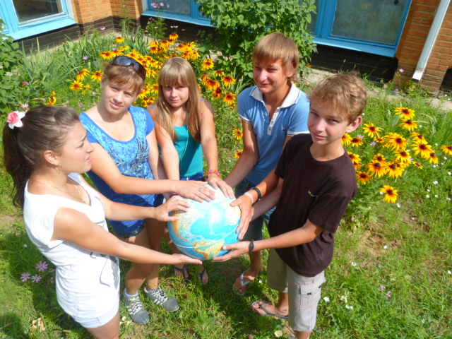
« TAKE NOTHING BUT PICTURES. LEAVE NOTHING BUT FOOTPRINTS.
KILL NOTHING BUT TIME».

